Calculating Principal Strains using a Rectangular Strain Gage Rosette


Strain gage rosettes are used often in engineering practice to determine strain states at specific points on a structure. Figure 1 illustrates three commonly used strain gage rosette configurations. Each of these configurations is designed with a specific task in mind. The far right rosette in Figure 1 is referred to as a tee rosette. Tee rosettes are two element rosettes and should only be used when the principal strain directions are known in advance from other considerations. The middle rosette in Figure 1 is referred to as a rectangular rosette and the far left as a delta rosette. These three element rosettes are used in applications where the principal strains are unknown. There are many other parameters that need to be taken into consideration when choosing a strain gage. Literature from manufacturers of strain gages provides some guidance in choosing the proper strain gage for a given application.
Figure 1: Examples of common Strain gage Rosettes encountered in engineering practice.
Figure 2: Illustration of the orientation of the rectangular strain gage rosette being evaluated in this example.
45°
45°
a
b
c
loop

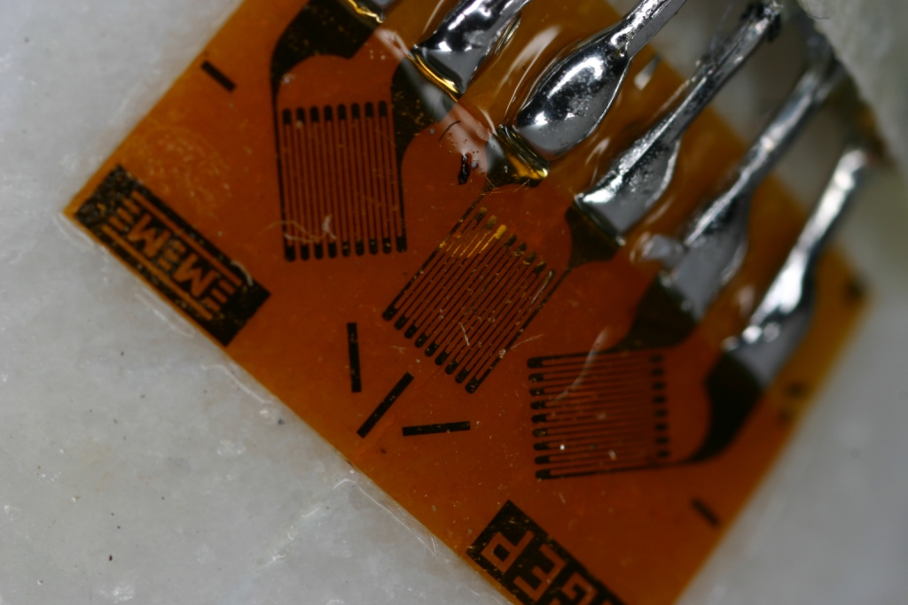
The primary focus of this treatise is the rectangular rosette. Figure 2 illustrates the numbering sequence and geometry that will be used in the following discussion. Figure 3 shows an actual rectangular strain gage rosette installed on a structure with the lead wires soldered onto the terminal tabs.
Figure 3: Rectangular strain gage rosette installed on a structure with lead wires attached.

In the remainder of this document the procedures for calculating principal strains from the strains that are read from a rectangular strain gage rosette are presented. First the correction of the raw strain readings for the loads transverse to the principal axis of the individual gages is presented. This is followed by a summary of the calculations used to compute principal strains directly from the corrected strain gage data. Finally a method used to calculate the principal strains from the corrected strain values using Mohr’s Circle is discussed.
Correcting Strain Gage Data

Each of the strain gages in a rosette is attached to separate bridge circuits through the lead wires. The type of bridge circuit used is a function of the application being considered. Under load, three strain values are recorded at each load increment. These raw strain readings are designated as the normal strains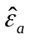, 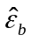, and 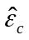. The “^” designates that the strain is a raw or uncorrected strain.

Strains on a rosette require correction because these gages are used on structures that are subjected to bi-axial states of stress. Error occurs as the loops in the strain gage grids (illustrated in Figure 2) are stretched transverse to the primary direction of the gage. The following equations summarize how the strain readings are corrected for the transverse loading of the gages in a rectangular rosette [1].

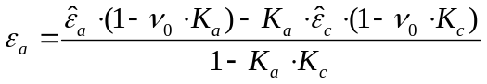 (1)

(2)

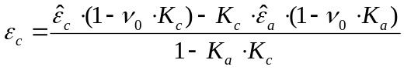 (3)

where 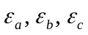 are the corrected strains; 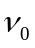 is Poisson’s ratio for the material used in calibration by the strain gage manufacturer (typically 0.285); and 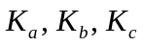 are the transverse sensitivity coefficients for the gages that are found on the manufacturer’s data sheet.

Direct Calculation of Principal Strains from Corrected Strains

The corrected strains are used in the calculation of the principal strains. The equations used to calculate the two principal strains from the corrected strains are summarized below [2].

(4)

(5)

where 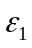 and 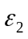 are the two in-plane principal strains. The calculation of the principal angle – the angle between the “a” axis (illustrated in Figure 2) and the maximum principal strain () – from the corrected strains is given by Equation 6 [2].

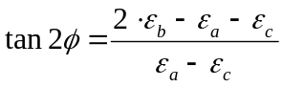 (6)

If the sample is fabricated from a material that is linear, isotropic, and homogeneous the principal stresses can be computed directly from the corrected strains as follows [2].

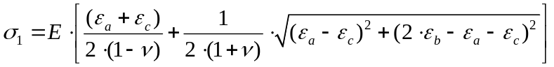 (7)

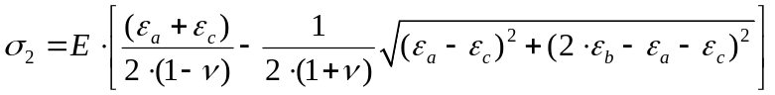 (8)

where  is the modulus of elasticity of the structural material and is Poisson’s ratio for the structural material.

Calculating Principal Strains Using Mohr’s Circle

Figure 4: Illustration of the orientation of the rectangular strain gage rosette on a pressurized cylindrical can.
b
45°
45°
a
c
axial
hoop
Formulas are often forgotten or remembered incorrectly. Although it is always possible to look formulas up, when data is being collected in remote locations references are not always available. An alternative way of calculating the principal strains and the principal angle from strain data is through the use of Mohr’s circle for strain. This technique does not require the use of Equations 4, 5, or 6. The development of the technique starts with the corrected strains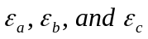.

To help the discussion of this development, an example of a rectangular strain gage rosette mounted on a beverage can for the purpose of determining the pressure internal to the soda can is used. Figure 4 illustrates the orientation of the rectangular strain gage rosette with respect to the major axes of the soda can. The strain gage nomenclature used in Figure 4 is the same as that used in Figure 2 (the orientation of the gages in the two figures is different to illustrate that the calculations are independent of gage orientation). It is very important to note that the major axes (principal stress and strain axes – axial and hoop axes) of the beverage can do not align with any of the gage axes.

In an experiment a rectangular strain gage rosette is mounted on a beverage can, the can is opened, and the following strains are recorded.

ε_{a*} = -1237(10⁻⁶) in/in (9)

ε_{b*} = -1270(10⁻⁶) in/in (10)

ε_{c*} = -402(10⁻⁶) in/in (11)

These strains result from depressurizing the can and is why they are designated with a “*”. In this example the can is pressurized in a manner such that the material behaves linear-elastically. If the strain gages were mounted while the can was opened and then pressurized, the magnitude of the strains would be the same as in Equations 9, 10, & 11; however, they would all be positive. Since the primary interest here is the calculation of the pressure inside the can, the positive strains will be used and are summarized below without the “*” designation.

|ε_{a*}|= ε_{a} = 1237(10⁻⁶) in/in = 1237με (12)

|ε_{b*}|= ε_{b} = 1270(10⁻⁶) in/in = 1270με (13)

|ε_{c*}|= ε_{c} = 402(10⁻⁶) in/in = 402με (14)

Strain is often referred to in units of micro-strain (με) in engineering applications.

In the remainder of this subsection the determination of the pressure in this can will be discussed. First the construction of Mohr’s circle for strain for the purpose of determining the principal strains will be described. This will be followed by a discussion of how the principal stresses are calculated from the principal strains for a bi-axial state of stress. Finally, the pressure in the soda can will be calculated using pressure vessel theory.

Construction of Mohr’s Circle for Strain

The construction of Mohr’s circle for strain starts with drawing horizontal normal strain (ε) and vertical tensor shear strain (γ/2) axes as illustrated in Figure 5. The corrected strains calculated in Equations 12, 13, and 14 are plotted on the horizontal axis in Figure 5 and designated with a “Ο”. The tensor shear strains that accompany these normal strains are unknown and therefore need to be calculated as part of the construction.

Because a rectangular strain gage rosette is being used, the center of Mohr’s Circle is located on the horizontal axis at the point given by the average of the two perpendicular gages, ε_{ave} (ε_{ave} is plotted on Figure 5).

(15)

Now a circle that is centered at ε_{ave} is scribed around the three strain values plotted on the horizontal axis. It is important to make sure that the circle completely encompasses all three strains. The diameter of the circle is not important at this point, a more exact circle can be drawn after the construction is complete.

After the circle is drawn, vertical lines are projected in both directions from the three location of the three states of strain for gages a, b, and c on Mohr’s Circle (ε_{a}, ε_{b}, ε_{c}). The proper location for each gage on the circle is determined by understanding that the angular orientation of the gages on the circle (a-b-c clockwise) must be the same as the angular orientation of the gages on the structure (a-b-c clockwise) and that any angle measured on the circle is twice the corresponding angel on the gage. Since the gages are 45° apart on the rosette shown in Figure 4, they have to be 90° apart on Mohr’s circle shown in Figure 5. It is therefore appropriate to assume that the three gages are in three different quadrants of the circle clockwise from “a” to “c”.

Using the orientation and angular constraints discussed in the previous paragraph the three of six points on Mohr’s circle that represents the state of strain on the surface can be determined. This process starts by determining which of points ε_{a1} and ε_{a2} represents the true state of strain. Consider first point ε_{a2}, moving to the next clockwise quadrant (90° clockwise) in Figure 5 point ε_{c1} is encountered. Strain gages “a” and “c” are clockwise 90° apart on the rosette shown in Figure 4 and therefore ε_{a} and ε_{c} should be clockwise 180° apart on Mohr’s circle. Since this is not the case, ε_{a2} can not represent the state of strain on the surface of the can. Now consider point ε_{a1}, moving to the next clockwise quadrant (90° clockwise) point ε_{b1} is encountered. Strain gage “a” and “b” are clockwise 45° apart on the rosette shown in Figure 4 and therefore ε_{a} and ε_{b} should be clockwise 90° apart on Mohr’s circle. Since this is the orientation observed on Mohr’s circle in Figure 5 points ε_{a1} and ε_{b1} represent the state of strain of the can. Continuing from point ε_{b1} to the next clockwise quadrant (90° clockwise from point ε_{b1}) in Figure 5, point ε_{c1} is encountered. Point “b” and point “c” are clockwise 45° apart on the rosette in Figure 4 and therefore ε_{b} and ε_{c} should be clockwise 90° apart on Mohr’s circle; this also is the observed orientation in Figure 5. It is therefore concluded that ε_{a1}, ε_{b1}, and ε_{c1} on Mohr’s circle for strain represent the states of strain being measured by the rectangular strain gage rosette. These points are designated with the filled circles (•) that lie on Mohr’s circle, but not on the horizontal axis in Figure 5.

The diameter of the circle needs to be determined. The two triangles scribed inside the circle using solid lines will be used to assist in this calculation. The horizontal distance between points ε_{a1} and ε_{c1} (ε_{a}ε_{c}) is the horizontal side of the lower triangles illustrated in Figure 5. This horizontal distance is calculated using the results from Equations 12 and 14 as follows.

| ε_{a} - ε_{c}| = |1237με-402με|=835με (16)

The horizontal dimension of the higher solid triangle in Figure 5 is twice the distance between ε_{b} and ε_{ave}. The calculation of this value follows using the results from Equations 13 and 15.

2| ε_{ave} - ε_{b}| = |ε_{a}+ε_{c} - 2ε_{b}| = 2⋅|819.5με-1270με| = 901με (17)
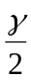
h₁
ε_{a}
ε_{b}
ε_{c}
|ε_{a}-ε_{c}|
ε_{ave}=½(ε_{a}+ε_{c})
|ε_{ave}-ε_{b}|
2|ε_{ave}-ε_{b}|=|ε_{a}+ε_{c}-2ε_{b}|
ε_{c2}
ε_{c1}
ε_{a1}
ε_{a2}
h₂
ε_{b2}
ε_{b1}
Figure 5: Mohr’s circle for strain used to illustrate the calculation of principal strains from the corrected strains collected off a rectangular strain gage rosette.
ε_{p2}
ε_{p1}
ε*
2⋅φ
2⋅φ

The determination of the diameter of Mohr’s circle in Figure 5 requires that either the vertical distance h₁ or h₂ is known. A heuristic approach is taken to determine the values of these vertical distances. Consider rotating the strain gage rosette illustrated in Figure 4 45° clockwise. This would be the same as moving point ε_{a1} to point ε_{b1} on Mohr’s circle and point ε_{c1} to point ε*. In doing so the lower triangle is rotated into the upper triangle, thus concluding that the two triangles are the same triangles just rotated 90° on Mohr’s circle. Therefore,

h₁ = 2| ε_{ave} - ε_{b}| = |ε_{a}+ε_{c} - 2ε_{b}| = 2⋅|819.5με-1270με| = 901με (18)

h₂ = | ε_{a} - ε_{c}| = |1237με-402με|=835με (19)

The diameter of the triangle can now be calculated using Pythagoras’s theorem.

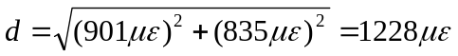 (20)

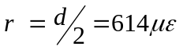 (21)

The principal strains ε_{p1} and ε_{p2} can now be calculated using the results in Equations 15 and 21.

ε_{p1} = ε_{ave} + r = 819.5με + 614με = 1433.5με = 1434με (22)

ε_{p2} = ε_{ave} - r = 819.5με - 614με = 205.5με = 206με (23)

The angle between the point ε_{a1} and point ε_{p1} on Figure 5, twice the principal angle φ, can be calculated using the results in Equations 18 and 19.

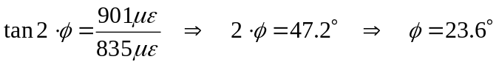 (24)

With the principal strains calculated, the principal stresses can now be determined.

Determination of the Principal Stresses from the Principal Strains

The relationship between the principal stresses (σ₁ and σ₂) and the principal strains (ε_{p1} and ε_{p2}) is referred to as Hooke’s Law. For the bi-axial state of stress in this problem, Hooke’s law reduces to the following two equations.

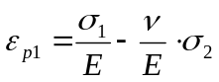 (25)

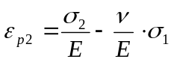 (26)

where E is the modulus of elasticity or Young’s modulus and υ is Poisson’s ratio. Equations 25 and 26 are solved simultaneously in order to form equations for σ₁ and σ₂ as functions of ε_{p1} and ε_{p2}.

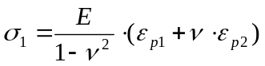 (27)

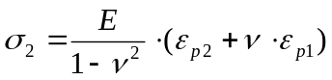 (28)

For an aluminum soda can the modulus of elasticity is approximately 10.4 Msi and Poisson’s ratio is 0.32. The results in Equations 22 and 23 can now be substituted into Equations 27 and 28 in order to determine the principal stress in the soda can.

(29)

(30)

With the principal stresses calculated, pressure vessel theory can be used to calculate the internal pressure of the soda can.

Using Thin Walled Pressure Vessel Theory to Calculate the Pressure in a Can of Soda

The principal stresses σ₁ and σ₂ correspond to the circumferential (hoop) and axial stresses, respectively. From the theory of thin walled pressure vessels these stresses can be calculated in terms of the internal pressure as follows.

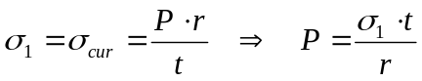 (31)

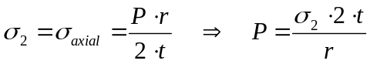 (32)

where P is the internal pressure in the can, r is the radius of the can, and t is the thickness of the can. For this particular soda can the radius of the can was measured to be r=1.3in and the thickness of the can was measured to be t=0.005in. Equations 31 and 32 can both be used to calculate the internal pressure in the can.

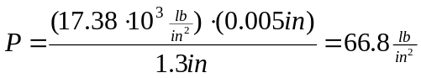 (33)

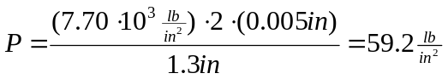 (34)

Equations 33 and 34 provide independent estimations of the pressure in the soda can. The difference between Equations 33 and 34 represents the experimental error. In the absent of experimental error these two values whould be identical.

Summary of the Use of a Rectangular Strain Gage Rosette

The three element strain gage rosette allows the calculation of the principal strains when their principal direction is not known ahead of time. The calculations of the principal strains and stresses in a rectangular strain gage rosette (0-45-90 gage orientation) are summarized in Equations 4, 5, 7, and 8. The calculation of the principal strains from the results of a rectangular strain gage rosette can also accomplished with the construction of Mohr’s circle for strain. This method has the advantage that Equations 4, 5, 7, and 8 do not have to be committed to memory. This method also provides considerable more insight into the state of strain in the soda can.

References

[1] MicroMeasurements Group Technical Note TN-509, “Transverse Sensitivity Errors,” Measurements Group, Inc., 1993.

[2] Dally, J.W., & William, F.R., “Chapter 9: Strain-Analysis Methods,” Experimental Stress Analysis, 3rd ed., McGraw-Hill, Boston, 1993, p.313-315.

